Name: _______________________ Student Number: _____________

**Mock exam**

**General Chemistry for Engineers**

Date: Dec 16, 2022

Total Points: 100 Time: 10:30 AM - 11:30 AM

Course Tutor: M. Hassan

**Instruction:** Attempt all the questions. Course book, Periodic Table & Calculator are allowed.

**Part I.** Circle your answers for multiple-choice questions.

**1. Which element below has the highest electronegativity? (2 points)**

A). C B). P C). N

D). B E). Be

**2. Circle the correct answer for each of the following: (6 points)**

a) the lowest electronegativity: **F, Cl, P**

b) would be most likely to form a stable anion with a –2 charge: **Se, Cl, Mg**

c) is diamagnetic: **F, Fe3+, Na+**

**3.** **Which of the following bonds is most ionic?** **(2 points)**

a) H-Cl b) F-Cl c) O-Cl

d) Cs-Cl e) Li-Cl

**4. What volume of 10.0 M H2SO4 is required to prepare 4.0 L of 0.50 M H2SO4? (4 points)**

A) 0.20 L B) 0.40 L C) 0.50 L

D) 1.0 L E) 4.0 L

**5. Which of the following options is the structure of a *p*-type semiconductor? (Based on the separated part of the table on the right) (2 points)**

|  |  |  |  |  |
| --- | --- | --- | --- | --- |
| **1)** |  | **2)** |  |  |
| **3)** |  | **4)** |  |

**6. Name the specified phase changes? (A, B, and C) (2 points)**

|  |  |  |  |  |
| --- | --- | --- | --- | --- |
| **1)** | A) Freezing  B) Sublimation  C) Melting | **2)** | A) Dispersion  B) Condensation  C) Sublimation |  |
| **3)** | A) Melting  B) Evaporation  C) Condensation | **4)** | A) Freezing  B) Evaporation  C) Sublimation |

**7.** **Which of the following quantum number sets describes a *4f* orbital? (5 points)**

A) *n*=2, *l*=0, ml = 0 B) *n*=3, *l*=1, ml = -1

C) *n*=3, *l*=2, ml = -1 D) *n*=4, *l*=2, ml = +1

E) *n*=4, *l*=3, ml = +2

**8. Which option can schematically illustrate the formation of a “Covalent bond”? (2 points)**

|  |  |  |  |
| --- | --- | --- | --- |
| **1)** |  | **2)** |  |
| **3)** |  | **4)** |  |

**9. Which of the following kinds of electromagnetic radiation has the highest energy per photon?** **(2 points)**

a) visible light b) ultraviolet light c) infrared light

d) microwaves e) radio waves

**10.** **If the ∆H° for the reaction, 2Mg (s) + 2Cl2 (g) → 2MgCl2 (s), is -1283.6 kJ, what is the standard enthalpy of formation of magnesium chloride? (4 points)**

A) 0 kJ/mol B) -320.9 kJ/mol

C) -641.8 kJ/mol D) 1283.6 kJ/mol E) -1283.6 kJ/mol

**11. Which intermolecular bonding brings the strongest connection between atoms? (2 points)**

|  |  |  |  |
| --- | --- | --- | --- |
| **1)** | London dispersion (Van der Waals Forces) | **2)** | Ion-dipole |
| **3)** | Dipole-dipole | **4)** | Hydrogen bonding |

**12. “Malleability” is one of the most important properties of metals, what does it mean? (2 points)**

|  |  |  |  |
| --- | --- | --- | --- |
| **1)** | ability to glow or reflect light | **2)** | ability to conduct electricity |
| **3)** | ability to be shaped by physical force | **4)** | ability to be stretched into long wires |

**Part II.** Short/Long Answers and Calculations. *To get full credit you must show all your work!*

**11.** What is the SO42- concentration of a solution prepared by dissolving 3.00 g of Na2SO4 in 1.00 L of water? **(5 points)**

**12.** Write the electron configuration of the following species: **(4 points)**

Cr: ____[Ar] 4s2 3d5_____________________

Zr3+: ____[Kr]3d1_______________________

**13. Write the chemical formula and name chemical compounds.**

**A)** Write the chemical formula for the following compounds: **(4 points)**

a) cadmium (II) sulfide ______CdS__________________

b) potassium perchlorate ______KClO4________________

**B)** Name the following compounds: **(4 points)**

a) SiO2 ________Silicon dioxide____________________

b) BaCO3 _______barium carbonate_________________

**14.** Like all carbonates, barium carbonate can be decomposed into metal oxide and CO2.

BaCO3 (s) BaO (s) + CO2 (g)

If the ΔHrxn of barium carbonate decomposition is 269.3 kJ/mol, how many kJ are required to decompose 10.0 g of BaCO3? **(5 points)**

(13.6 kJ)

**15.** Styrene is a compound consisting of C and H. Combustion of 4.21 10-3 moles of styrene produce 1.481 g of CO2 and 0.303 g of H2O. **(5 points)**

a) What is empirical formula of styrene?

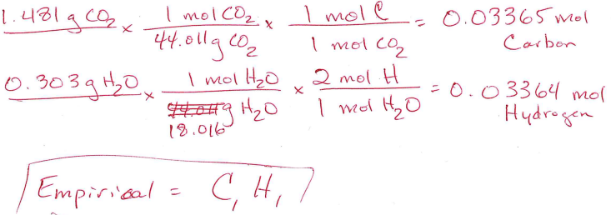 C1H1

b) What is molecular formula of styrene?

C8H8

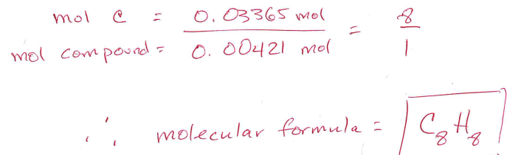

**16.** Predict the products when the following reagents react. Indicate what type of reaction takes place. **(6 points)**

a) C3H8 + O2 _CO2___ + H2O

Type of reaction: ____Combustion reaction_________________

(b) Pb(NO3)2 (*aq*) + NaI (aq) ___ PbI2(s)____ + ___ NaNO3(aq)____

Type of reaction: ___Precipitation reaction_____________________

(c) HCl + NaOH __NaCl____ + ___H2O_____

Reaction type: _____Neutralization reaction (Acid-base reaction) _______

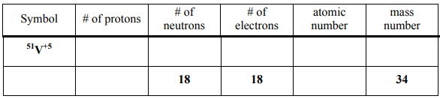**17.** Complete the following table (all empty cells in both rows): **(5 points)**

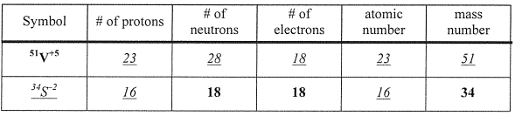

**18.** The combination of coke and steam produces a mixture called coal gas, which can be used as a fuel or as a starting material for other reactions. The equation for the production of coal gas is

2C(s) + 2H2O(g) CH4 (g) + CO2 (g)

Determine the standard enthalpy change for this reaction based on the following standard enthalpies of the reaction: **(6 points)**

C(s) + H2O(g) CO(g) + H2 (g) ΔH = +131.3 kJ

CO(g) + H2O(g) CO2 (g) + H2 (g) ΔH = –41.2 kJ

CH4 (g) + H2O(g) 3H2 (g) + CO(g) ΔH = +206.1 kJ

= 15.30 kj/

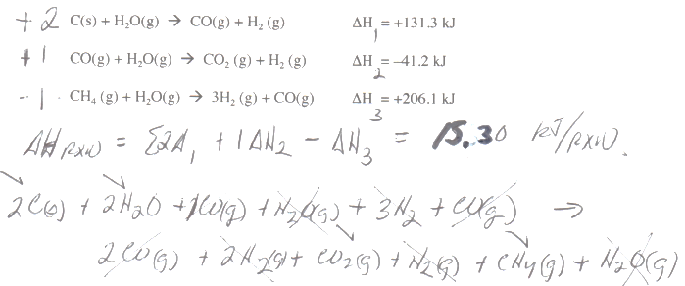

**19.** A mixture of 0.2 mol N2 (g) and 0.3 mol Ar (g) are in a container of unknown volume. The pressure inside the container is 1.0 atm and the temperature is 0C. What is the volume of the container? **(5 points)**

10 L

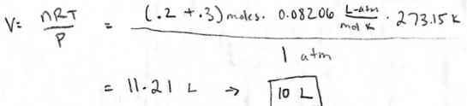

1. Calculate the pressure exerted by a 4.25 L gas container containing 3.46 mol of CO2 at a temperature of 229 oC, using
2. the ideal gas law and
3. van der Waals equation [*a* = 3.59 atm. L2/mol2 and *b* = 0.0427 L/mol) **(8 points)**

(Pideal = 33.5 atm

Preal = 32.4 atm)

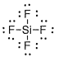**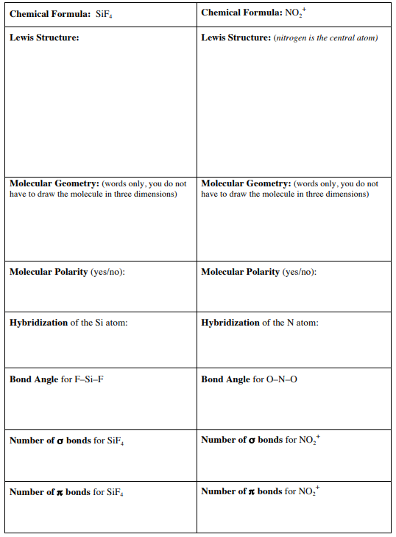21.** Complete the Table (**either SiF4 or NO2+**). **(8 points)**